Case 19-AM,C-Taino-Pendant-Owl Theriomorph-Manatee Rib

This pendant is made of manatee bone, likely from a jaw or mandible. The owl face motif has spiral eyes likely indicating a hallucinogenic trance state in which spirals were one of the entoptic images visually experienced. Birds, especially nocturnal birds such as owls, were the shaman’s ally to help him navigate the spiritual universe especially during the darkness of night. When the piece is turned 180 degrees another face can be seen. This duality of conjoined images is a common Taino design feature often occurring in spiritual art. The pendant measures 8.0 cm. or 3.1 in. and is attributed to the Dominican Republic. Dating ca. 1000-1500 C.E.

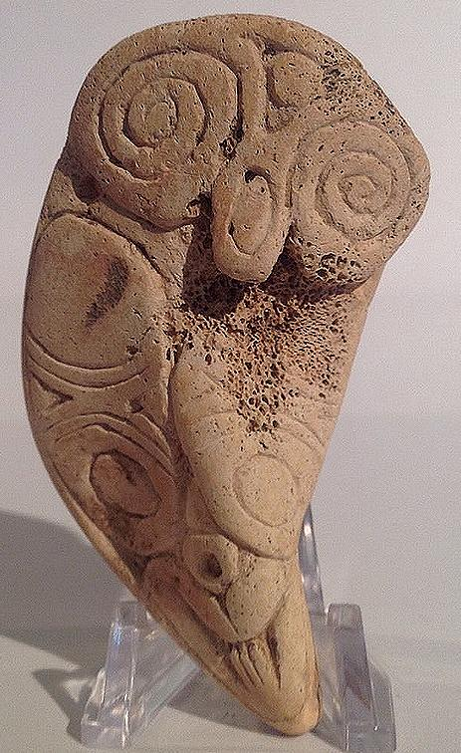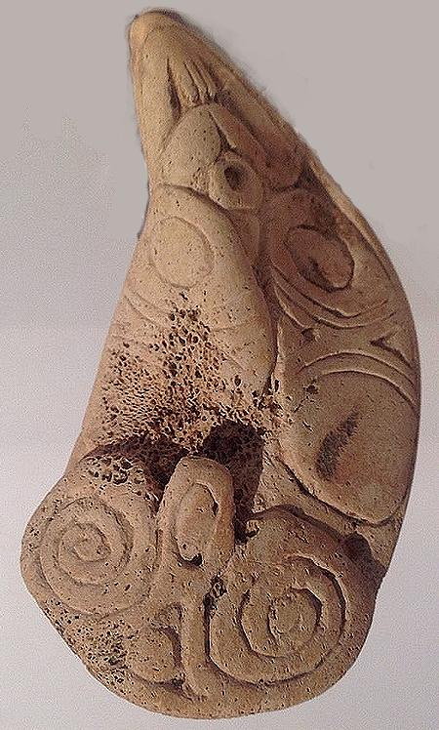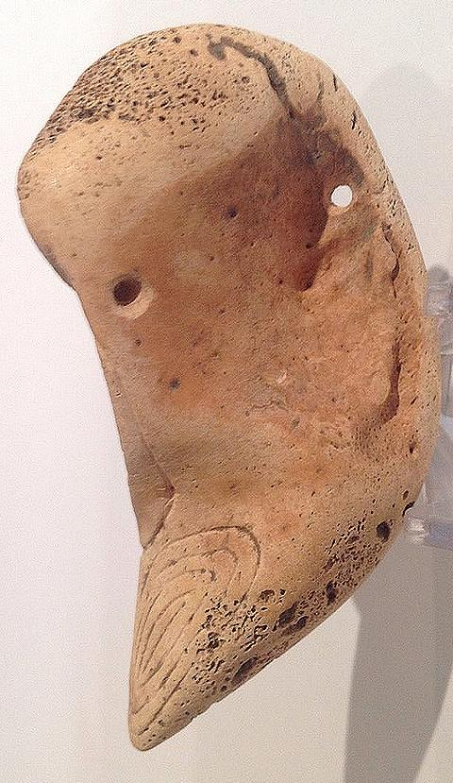

Rather small manatee bone pendant depicting a goddess pushing her belly and vaginal symbol at base. Nice little compact figure. Length 4.4 cm. or 1.7 in.originally from Hispaniola. Dating ca. 1000-1500 C.E.

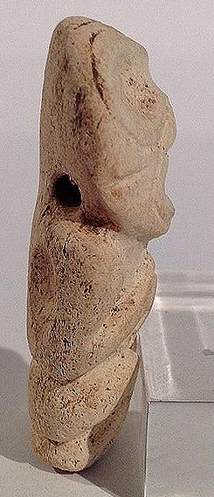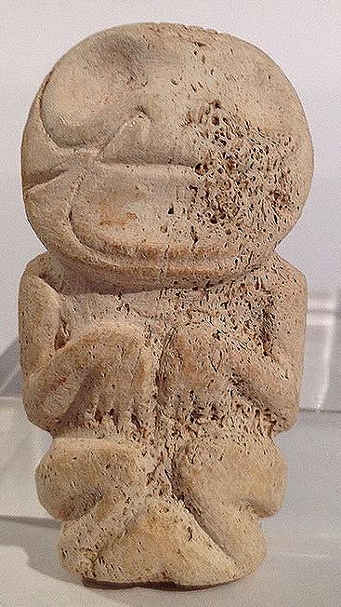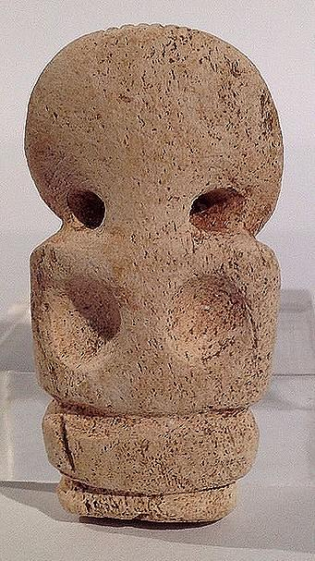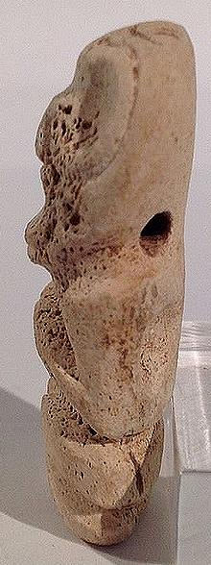

Female symbolic details define the bird mother: typical birthing pose with hands on belly pushing and baby bulge between knees. Birds are closely associated with femininity because of their care for the young. The little bird mother is well conceived and fully decorated front and back. A secondary bird face appears on beak. She is likely made of naturally stained marble. Length is 5.2 cm. or 2 in. 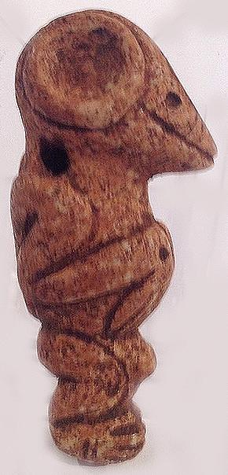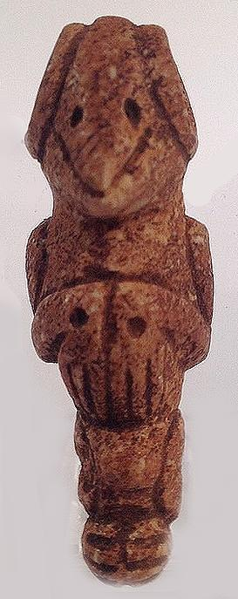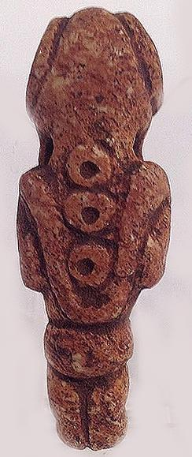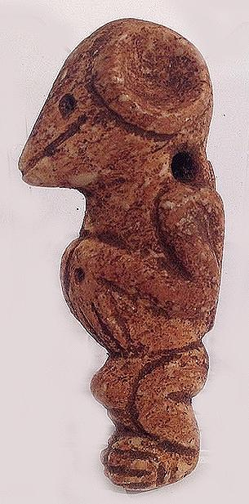

Sold by [flapast](http://myworld.ebay.com/flapast) ( [13311](http://feedback.ebay.com/ws/eBayISAPI.dll?ViewFeedback&userid=flapast) )

### Delivery package 1 of 1

Estimated delivery Monday, Jan 25, 2016

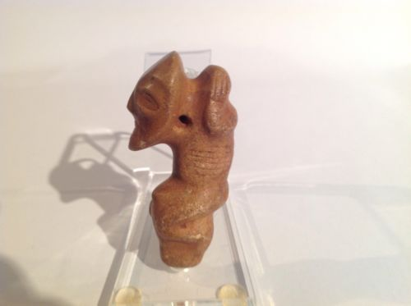

#### [Taino Stone Pendant Anthropic Female Figure, Pre Columbian](http://www.ebay.com/itm/252240642082)

|  |  |
| --- | --- |
| Item price | $112.50 |
| Quantity | 1 |
| Item number | 252240642082 |
| Shipping service | USPS First Class Package |

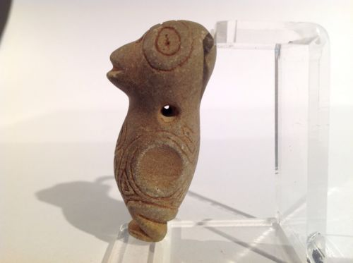

#### [Taino Stone Bird Woman Pendant, Pre Columbian](http://www.ebay.com/itm/252241215035)

|  |  |
| --- | --- |
| Item price | $75.00 |
| Quantity | 1 |
| Item number | 252241215035 |
| Shipping service | USPS First Class Package |

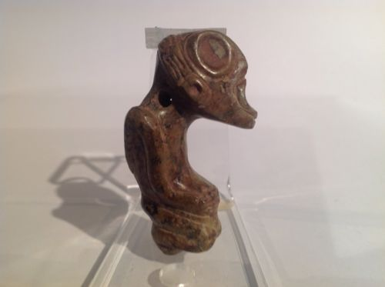

#### [Taino, Serpentine Pendant Anthropic Figure Pre Columbian](http://www.ebay.com/itm/262228120730)

|  |  |
| --- | --- |
| Item price | $190.27 |
| Quantity | 1 |
| Item number | 262228120730 |
| Shipping service | USPS First Class Package |

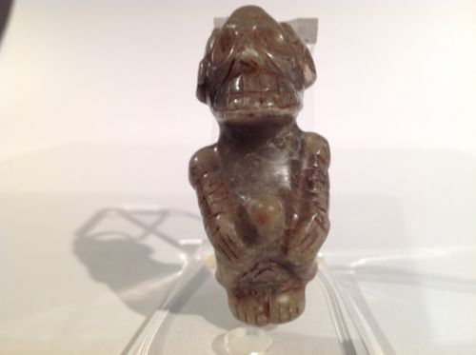

#### [Taino Marble Anthropic Cacique Pendant. Pre Columbian](http://www.ebay.com/itm/262228144371)

|  |  |
| --- | --- |
| Item price | $207.50 |
| Quantity | 1 |
| Item number | 262228144371 |
| Shipping service | USPS First Class Package |

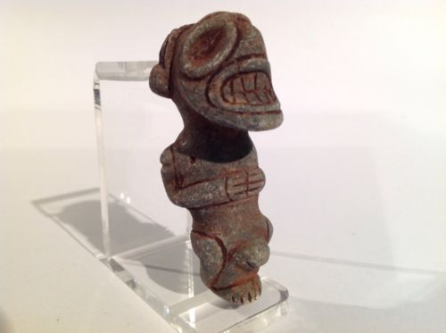

#### [Taino Stone Pendant, Atabey Goddess Of Fertility Pre Columbian](http://www.ebay.com/itm/262228662198)

|  |  |
| --- | --- |
| Item price | $132.50 |
| Quantity | 1 |
| Item number | 262228662198 |
| Shipping service | USPS First Class Package |

## Shipping address

Ralph J Coffman Jr

149 Atlantic Ave

Swampscott MA 01907-2427

United States

## Order total

|  |  |
| --- | --- |
| Subtotal | $867.77 |
| Shipping | $42.00 |

**Total**

$909.77

Order placed on

Saturday, Jan 16, 2016

Payment method

PayPal

Payment date

Saturday, Jan 16, 2016

Sold by [flapast](http://myworld.ebay.com/flapast) ( [13311](http://feedback.ebay.com/ws/eBayISAPI.dll?ViewFeedback&userid=flapast) )

### Delivery package 1 of 1

Estimated delivery Tuesday, Jan 26, 2016

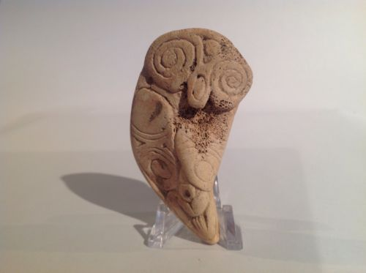

#### [Taino Large Bird Like Figural Pendant, Pre Columbian](http://www.ebay.com/itm/252240691373)

|  |  |
| --- | --- |
| Item price | $50.00 |
| Quantity | 1 |
| Item number | 252240691373 |
| Shipping service | Economy Shipping |

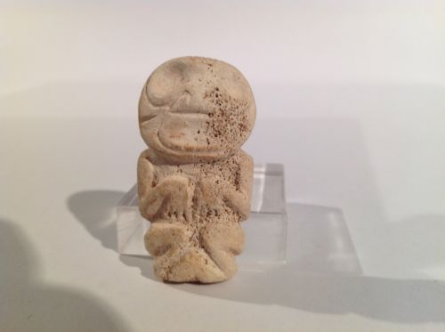

#### [Taino Anthropic Pendant, Female Goddess, Pre Columbian](http://www.ebay.com/itm/252241232950)

|  |  |
| --- | --- |
| Item price | $100.00 |
| Quantity | 1 |
| Item number | 252241232950 |
| Shipping service | Economy Shipping |

Sold by [flapast](http://myworld.ebay.com/flapast) ( [13311](http://feedback.ebay.com/ws/eBayISAPI.dll?ViewFeedback&userid=flapast) )

### Delivery package 1 of 1

Estimated delivery Monday, Jan 25, 2016

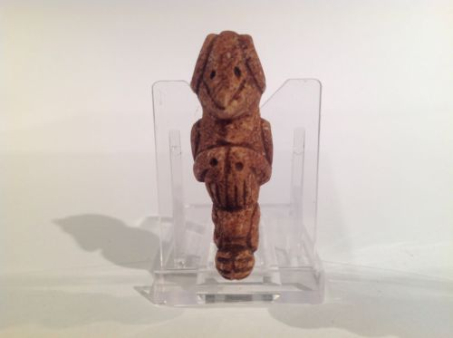

#### [Taino Stone Bird Mam (female) Transformation Pre Columbian](http://www.ebay.com/itm/252241262679)

|  |  |
| --- | --- |
| Item price | $70.00 |
| Quantity | 1 |
| Item number | 252241262679 |
| Shipping service | USPS First Class Package |

## Shipping address

Ralph J Coffman Jr

149 Atlantic Ave

Swampscott MA 01907-2427

United States

## Order total

|  |  |
| --- | --- |
| Subtotal | $70.00 |
| Shipping | $6.00 |

**Total**

$76.00

Order placed on

Saturday, Jan 16, 2016

Payment method

PayPal

Payment date

Saturday, Jan 16, 2016